The Michigan Abolitionist Project, Pt. Huron Community Group
is hosting beloved residents & staff of Freedom House
at a PICNIC on HARSENS ISLAND
on Saturday, July 14, 11 a.m. - ??
YOU are most welcome to join in the fun & catch a glimpse of heaven!!
Freedom House Detroit is a temporary home for indigent survivors of persecution from around the world who are seeking asylum in the United States and Canada. Our mission is to uphold a fundamental American principle, one inscribed on the base of the Statue of Liberty, providing safety for those “yearning to breathe free.” In 2012 we became a formal partner in the Northern Tier Anti-Trafficking Consortium servicing victims of human trafficking. Residents came from 28 different countries in 2017. Freedom House’s mission statement reads:
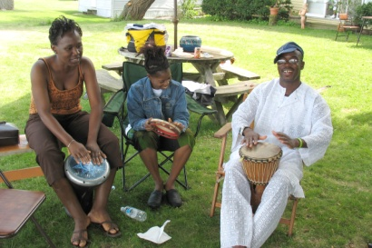
Guided by our belief that all persons deserve to live free from oppression and to be treated with justice, compassion and dignity, we offer a continuum of care and services to our residents as well as to other refugees in need. We advocate for systemic change that more fully recognizes the rights of asylum seekers.
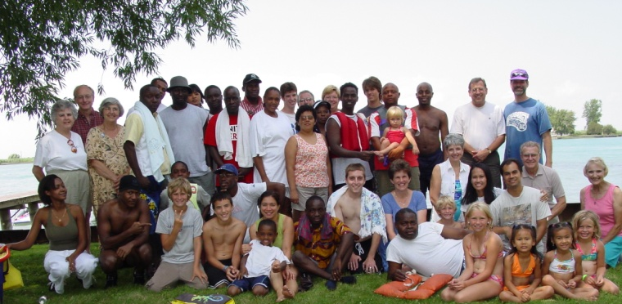
The PICNIC will be a potluck where everyone gathered will
feast on friendship – food – fun in the sun! Bring your bathing suit!
We have plenty of life jackets – towels – sunscreen!
Pick from a boat ride - kayak – canoe – paddle board – inner tube &/or
you can stay on land and play volleyball – soccer – music – lawn games!
PLUS everyone will enjoy rich conversation with beautiful people from all over the world (literally!!) RSVP to Theresa email porthuron@map-mi.org or call (810) 748-9528 (landline)
NOTE: it costs $10/car (roundtrip) on the ferry It is sure to be a memorable day for your whole family!!

